Ian Bishop

BIO-594_2019

4/16/19

**Title: The adaptive potential of Southern Ocean phytoplankton**

**Overview**

Global climate change is upon us and species must now cope with rapid environmental change, especially in polar ecosystems. For many cold-adapted species in the Southern Ocean, adaptation, mostly likely via lineage sorting of standing genetic diversity and phenotypic plasticity, is the only way to persist. Diatoms, an ecologically important and highly diverse group of algae, have in recent years been found to maintain extensive intraspecific genetic and phenotypic diversity, yet very little is known about a) how this this selectable variation is structured spatially in the SO; and b) the extent to which epigenetic processes help determine their adaptive potential. This knowledge gap directly corresponds to the lack of adoption of what are by now well-established next generation sequencing methods, most notably reduced-representation sequencing (RRS). *We propose to examine the abundance and spatial distribution of critical determinants of adaptive potential, namely genetic and epigenetic polymorphism. We intend to develop and implement both common genomic and developing epigenomic methods, neither of which have been utilized in eukaryotic photoautotrophs.*

**Intellectual Merit**

Our research effort would advance marine protistan ecology in several important ways. First, to the best of our knowledge, there have been no published attempts to either: A) apply population genomic methods to eukaryotic phytoplankton; or B) determine within even an order of magnitude the variation in epigenetic markers in populations of eukaryotic phytoplankton. Not only the structural variation findings, but also the optimization efforts developed for this project will be published open source to facilitate broader implementation of such methods in protist population genomics.

Presently, most climate change models assessing extinctions, species distribution and diversity do not parameterize evolutionarily important features such as population level (epi)genomic diversity and phenotypic plasticity, even though their influence on phytoplankton standing stock may be substantial and may adjust the scale of several climate-related biogeochemical feedback loops. Even a coarse understanding of the raw material (genetic and epigenetic variation) of adaptation, where and how it varies in the Southern Ocean, has much to contribute to this effort.

**Broader Impacts**

We will reach out to Rhode Island environmental organizations and school age children to increase both awareness and understanding of the local to global significance of some of the “good microbes”, i.e. microscopic algae. Students, via day events and short internships will have the opportunity to collect and visualize such organisms through high-powered compound microscopes and SEMs that which they are not able to see on a daily basis but greatly impact our life on earth.

1. **Background**

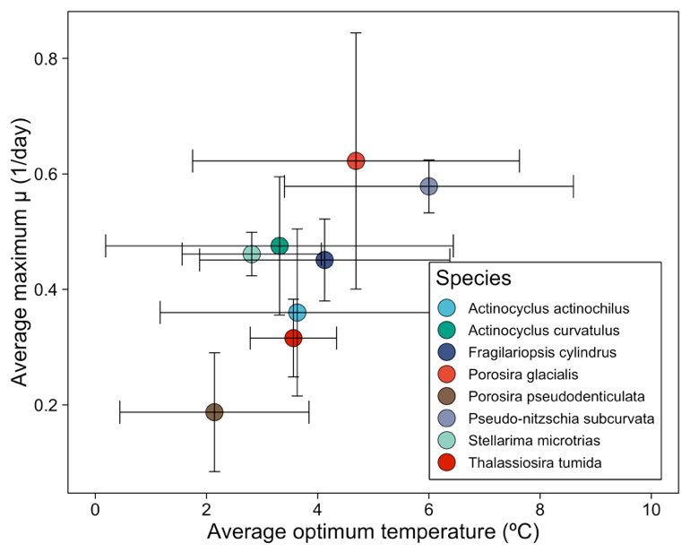The Southern Ocean (SO) is central to multiple global biogeochemical cycles, including Si, N, P, & Zn (Tréguer & De La Rocha 2013, Yool & Tyrrell 2013,Sarmiento et al. 2004,Vance et al. 2017). It is home to very productive, if patchy, phytoplankton communities, particularly north of the Antarctic Polar Front (APF) and along the Antarctic continental shelf (Moore & Abbott 2000). Given this central biogeochemical role, it is vital that we understand the extent to which these communities are at risk from rapid environmental change in the polar surface ocean. Sea surface temperature, salinity, and sea-ice extent will all shift in the coming century, but magnitude and direction of change will vary by region and depth (Constable et al. 2014).

In response to change, SO phytoplankton face either extinction or survival via adaptation (migration is not an option for cold-adapted organisms already up against the ice). Hence, any prediction of phytoplankton abundance, diversity and distribution must rely on an estimate of adaptive potential across the regional communities. One indication that phytoplankton species maintain the capacity to adapt to expected changes in SST is recently observed intraspecific variability in thermal plasticity (Fig. 1). These (unpublished) results document unexpectedly large intra- and inter-specific variation in thermal tolerance in several diatom species. This standing plasticity in response to what will mostly likely be the dominant driver of environmental change represents a possible major source of variation upon which selection can act, likely more relevant to adaptive potential than beneficial de novo mutation (Barrett & Schluter 2008; Matuszewski et al. (2015).

Figure 1. Forty-eight diatom strains representing 7 Southern Ocean diatom species show extensive variability in strain specific thermal optima and maximum growth rate.

While appreciation for polar diatom phenotypic plasticity is slowly increasing, mechanisms that underpin it, namely standing heritable genetic and epigenetic variation and its spatial structure, are currently poorly understood. Traditional methods (e.g. microsatellites and amplified fragment length polymorphisms, AFLP) have documented genetic differentiation in diatoms at both local and global scales (Rynearson & Armbrust 2000, Rynearson & Armbrust 2004, Whitaker & Rynearson 2017), sometimes stably persisting for nearly a century, or 40,000+ generations (Härnström et al. 2011). Global patterns of isolation by distance have also been documented (Casteleyn et al. 2010). These findings in conjunction with short generation times and the widely differing environmental conditions among SO sub-basins support the prediction that strongly differentiated diatom populations exist in the Antarctic.

More nebulous is the extent to which heritable epigenetic variation has contributed to local adaptation and phenotypic plasticity in diatoms, polar or otherwise. To date, methylation patterns have been documented in only a choice few model diatom species, where genome-wide methylation ranges from 1-50% (Rastogi et al. 2015). Where abundant, regions of high methylation are found in both coding regions, but also in a diverse assemblage of transposable elements, both of which are regions where heritable epialleles can alter expression and drive phenotypic plasticity (Traller et al. 2016).

What is required above all to examine the relative contribution of epigenomic and genomic variation to phenotypic plasticity is the implementation of modern next generation population (epi)genomic methods. To date, whole-, partial- or reduced-representation sequencing have not been applied to diatoms or any other eukaryotic phytoplankton (Rengefors et al. (2017), representing a major roadblock to algal population ecology and progress toward characterizing adaptive potential in at-risk phytoplankton across the global ocean.

1. **Specific Aims**

We seek to determine circumpolar population structure in SO diatoms and how epigenetic variation maps onto that structure. We know already that diatoms across the SO are phenotypically diverse and are possibly locally adapted across the region, but specific nucleotide and methylation polymorphic patterns are unknown. This knowledge gap is in part due to long held beliefs about robust gene flow in microbes and slow adoption of NGS methods to determine otherwise. We propose the following:

***Specific Aim 1:*** To optimize and apply cost-efficient next generation population genomic methodology to measure population structure in common planktonic diatoms in the Southern Ocean.

***Specific Aim 2:*** To examine genome-wide patterns in epigenetic variation across locally adapted populations of common planktonic diatoms in the Southern Ocean.

1. **Aim 1.**

Our first aim is to apply reduced-representation sequencing (RRS) to diatom populations from the Southern Ocean. Specifically, we will optimize the double digest restriction-site associated DNA method (ddRAD-seq; Peterson et al. 2012), to measure basin scale population differentiation within two diatoms, *Thalassiosira rotula* Meunier and *Actinocyclus actinochilus* (Ehrenb.) Simonsen. The former is regionally abundant yet its biogeographic distribution could be considered cosmopolitan, as it is found in coastal and open ocean contexts at high and low latitudes. The latter species is less common yet well-distributed south of the Antarctic circumpolar current (ACC). In addition to their distinct biogeographic profiles, these diatoms are phylogenetically distant from each other (Theriot et al. 2010).

We plan to analyze samples recently collected on a Southern Ocean research cruise (NBP1701) aboard the R/V Nathaniel B. Palmer (Fig. 2). Hundreds of single cell isolates for each species were collected in unique bioregions across four sub-basins and established in batch cultures. Archived DNA material exists for all samples, and many are still actively maintained in culture for experimentation. In addition to these materials, several control strains collected both from the SO and as far away as the North Sea will be included in sequencing runs. These controls will provide outgroups to any SO population structure we find.

The proposed RADseq method development will take advantage of both multiple high quality transcriptomes (Rubin et al. in review) and unpublished low coverage genomes. However, analysis will ultimately be conducted in absence of a reference genome, as very few diatoms have been sequenced (though the first, *Thalassiosira pseudonana,* is closely related to *T. rotula*), and it is our intention to facilitate RADseq use more broadly in natural microbial populations.

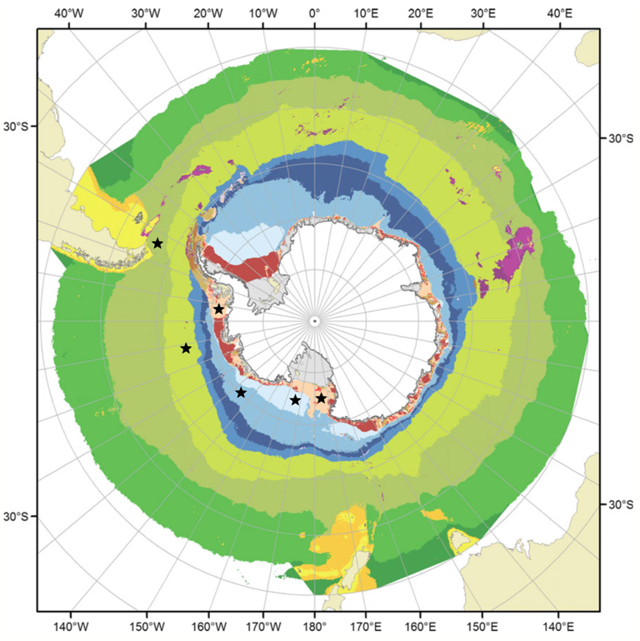Loci assignment in entangled host-microbiome systems without a reference genome presents a major hurdle ahead of successful use of RRS methods in algal species. While delicate tissue-extraction methods can be applied in macroscopic hosts (e.g. van Oppen et al. 2011), microbial host separation is more complicated. A majority of culture-extracted DNA can be non-host in origin, so pre-extraction solutions will work best. Our approach will be to knock back the microbiome with antibiotic cocktails to limit the bacterial DNA yield in as many samples as we can (e.g. Shishlyannikov et al. 2011). This will enable us to restrict downstream SNP calling in all samples, archival DNA or yet-to-be extracted, to loci genotyped in knock-down axenic samples.

Population structure across SO bioregions will be explored via multiple common analyses, including PCA, ADMIXTURE, and treemix (e.g. Jordan et al. 2018, Kautt et al. 2016). All three will be conducted on “neutral” SNPs, i.e. those that pass a study-specific optimal filtering protocol and several attempts to identify Fst outlier loci using algorithms that each assume different demographic histories, which in our case can be guessed at but are generally unknown. We hypothesize that as a result of short generation times and distinct environmental sub-basins, diatom individuals will strongly sort by region, possibly demonstrating an isolation-by-distance signal in the above analyses. Alternatively, strong physical connectivity between these basins driven by the ACC may promote substantial admixture, with the possible exception of samples collected in the northern Drake Passage, which is separated from all other samples by the Antarctic Polar Front.

Figure 2. Bioregions of the Southern Ocean (adapted from Constable et al. 2014). Stars indicate 6 unique Pacific sector bioregions visited during the NBP1701 research cruise.

1. **AIM 2.**

In tandem with the above aim of characterizing genomic polymorphism, we will develop a diatom-specific reduced representation bisulfite sequencing (RRBS) protocol, based on bsRAD-seq (Trucchi et al. 2016), to inquire into genome-wide epigenetic variability across distinct regional diatom populations.

One way in which epigenetic variation may drive population differentiation and local adaptation in the SO is through methylation-driven changes in transposable element (TE) activity. Methylation and TEs are strongly tied in higher plants (Rabinowicz et al. 1999; Slotkin et al. 2009), and while TE activity was once thought to be less common in smaller genomes of predominantly asexual organisms, newly characterized activity in fungi challenge this view (Lopes et al. 2009). In the few model diatoms for which methylomic data has been collected, there exists a great range of methylated DNA (1-50%; Traller et al. 2016; Tanaka et al. 2016). Copia-type LTR TEs in particular have been noted as highly methylated in at least one model diatom species (Veluchaumy et al. 2013). Hence, bsRAD-seq datasets will be examined with particular regard to the diatom repeatome, given its potential to shape phenotype and isolate populations.

There are multiple advantages to choosing this specific RRBS method as a starting point. First, a reference genome is not necessary. Any hope that the proposed work will inform other algal or protist population research relies on the effective analysis of populations without reference genomes. This is because a miniscule fraction of marine protists have sequenced genomes (Sibbald & Archibald 2017), including 7 diatoms species out the richness estimates ranging from 30,000-100,000 species globally (Mann & Vanormelingen 2013). Second, it neatly aligns with our first specific aim of using ddRAD-seq to tease out population structure for these diatoms. bsRAD-seq itself requires two rounds of library preparation, one that includes a methylation-sensitive cut site and a second, identical to “traditional” ddRADseq that uses methylation-insensitive restriction enzymes. The sequencing of both libraries allows one to discriminate between single methylated polymorphisms (SMPs) and SNPs at the same RAD loci. The discernment between these two variant forms allows for the comparison of several (epi)genomic features: LD:MD (methylation disequilibrium), differences in SMP and SNP heterogeneity, SMP allele frequency at neutral vs outlier loci, etc. (Zhao et al. 2018). Developing an initial understanding of these relationships is a first step toward relating spatial patterns in plasticity and local adaptation to specific molecular level processes.

1. **Intellectual Merit**

The proposed research above will contribute significantly both to the more localized fields of diatom and phytoplankton ecology but also to broader efforts to incorporate ecological and evolutionary parameters into climate change modeling efforts. First, if funded this work would be the first to apply modern population genomics methods to eukaryotic phytoplankton. To date, only a couple of studies have examined marine cyanobacterial populations with next generation sequencing (NGS) methods, and these have utilized whole genome sequencing, which is far more difficult and expensive in larger, repeat-rich eukaryotic lineages. Further, no attempt has been made to optimize and apply more economical RRS methods to non-model microbial eukaryotes, and efforts to propel widely applied methods like RAD-seq into protist systems could transform the way we approach them.

Second, it is imperative that we understand how phenotypic plasticity, genetic and epigenetic diversity is structured in changing ecosystems, as spatial patterns in these features may help inform researchers about which regions may be most adversely affected by SO phytoplankton-mediated feedback loops that intensify ocean change. Species-specific molecular diversity as proposed here can offer much to coupled biophysical modeling efforts that currently neglect the adaptive potential of phytoplanktonic communities.

1. **Broader Impacts**

*Microbial Education for young students and local citizens*

In conjunction with the proposed research above, we intend to engage with local community environmental organizations and school age children to increase both awareness and understanding of the global significance of some of the “good microbes”, i.e. microscopic eukaryotic algae such as diatoms. We propose a public communication effort that combines student lab visits, short summer student internships and annual gatherings/presentations by lab members to help expose a wide array of non-specialists to the unsung biogeochemical workhorse that is the microbial photoautotroph. All funded engagement will center on hands-on learning, including collecting specimens from nearby localities, viewing organisms through high-powered compound microscopes, and identifying species to help connect audiences with that which they are not able to see on a daily basis but greatly impact our daily lives.

1. **Works Cited**

Barrett, R., & Schluter, D. (2008). Adaptation from standing genetic variation. *Trends in Ecology & Evolution*, *23*(1), 38–44. <https://doi.org/10.1016/j.tree.2007.09.008>

Casteleyn, G., Leliaert, F., Backeljau, T., Debeer, A.-E., Kotaki, Y., Rhodes, L., … Vyverman, W. (2010). Limits to gene flow in a cosmopolitan marine planktonic diatom. *Proceedings of the National Academy of Sciences*, *107*(29), 12952–12957. <https://doi.org/10.1073/pnas.1001380107>

Constable, A. J., Melbourne-Thomas, J., Corney, S. P., Arrigo, K. R., Barbraud, C., Barnes, D. K. A., … Ziegler, P. (2014). Climate change and Southern Ocean ecosystems I: how changes in physical habitats directly affect marine biota. *Global Change Biology*, *20*(10), 3004–3025. <https://doi.org/10.1111/gcb.12623>

Harnstrom, K., Ellegaard, M., Andersen, T. J., & Godhe, A. (2011). Hundred years of genetic structure in a sediment revived diatom population. *Proceedings of the National Academy of Sciences*, *108*(10), 4252–4257. <https://doi.org/10.1073/pnas.1013528108>

Jordan, R., Hoffmann, A. A., Dillon, S. K., & Prober, S. M. (2017). Evidence of genomic adaptation to climate in *Eucalyptus microcarpa* : Implications for adaptive potential to projected climate change. *Molecular Ecology*, *26*(21), 6002–6020. <https://doi.org/10.1111/mec.14341>

Kautt, A. F., Machado-Schiaffino, G., & Meyer, A. (2016). Multispecies Outcomes of Sympatric Speciation after Admixture with the Source Population in Two Radiations of Nicaraguan Crater Lake Cichlids. *PLOS Genetics*, *12*(6), e1006157. <https://doi.org/10.1371/journal.pgen.1006157>

Lopes, F. R., Silva, J. C., Benchimol, M., Costa, G. G., Pereira, G. A., & Carareto, C. M. (2009). The protist Trichomonas vaginalis harbors multiple lineages of transcriptionally active Mutator-like elements. *BMC Genomics*, *10*(1), 330. <https://doi.org/10.1186/1471-2164-10-330>

Mann, D. G., & Vanormelingen, P. (2013). An Inordinate Fondness? The Number, Distributions, and Origins of Diatom Species. *Journal of Eukaryotic Microbiology*, *60*(4), 414–420. <https://doi.org/10.1111/jeu.12047>

Matuszewski, S., Hermisson, J., & Kopp, M. (2015). *Catch Me if You Can: Adaptation from Standing Genetic Variation to a Moving Phenotypic Optimum*. 45.

Moore, J. K., & Abbott, M. R. (2000). Phytoplankton chlorophyll distributions and primary production in the Southern Ocean. *Journal of Geophysical Research: Oceans*, *105*(C12), 28709–28722. <https://doi.org/10.1029/1999JC000043>

Peterson, B. K., Weber, J. N., Kay, E. H., Fisher, H. S., & Hoekstra, H. E. (2012). Double Digest RADseq: An Inexpensive Method for De Novo SNP Discovery and Genotyping in Model and Non-Model Species. *PLoS ONE*, *7*(5), e37135. <https://doi.org/10.1371/journal.pone.0037135>

Rastogi, A., Lin, X., Lombard, B., Loew, D., Tirichine, L., & 1 Ecology and Evolutionary Biology Section, Institut de Biologie de l’École Normale Supérieure (IBENS), CNRS UMR8197 INSERM U1024, 46 rue d’Ulm 75005 Paris, France; (2015). Probing the evolutionary history of epigenetic mechanisms: what can we learn from marine diatoms. *AIMS Genetics*, *2*(3), 173–191. <https://doi.org/10.3934/genet.2015.3.173>

Rengefors, K., Kremp, A., Reusch, T. B. H., & Wood, A. M. (2017). Genetic diversity and evolution in eukaryotic phytoplankton: revelations from population genetic studies. *Journal of Plankton Research*. <https://doi.org/10.1093/plankt/fbw098>

Rynearson, T. A., & Armbrust, E. V. (2000). DNA fingerprinting reveals extensive genetic diversity in a field population of the centric diatom Ditylum brightwellii. *Limnology and Oceanography*, *45*(6), 1329–1340. <https://doi.org/10.4319/lo.2000.45.6.1329>

Rynearson, T. A., & Virginia Armbrust, E. (2004). Genetic differentiation among populations of the planktonic marine diatom Ditylum brightwellii (Bacillariophyceae): genetically distinct diatom populations. *Journal of Phycology*, *40*(1), 34–43. <https://doi.org/10.1046/j.1529-8817.2004.03089.x>

Sarmiento, J. L., Gruber, N., Brzezinski, M. A., & Dunne, J. P. (2004). High-latitude controls of thermocline nutrients and low latitude biological productivity. *Nature*, *427*(6969), 56–60. <https://doi.org/10.1038/nature02127>

Shishlyannikov, S. M., Zakharova, Y. R., Volokitina, N. A., Mikhailov, I. S., Petrova, D. P., & Likhoshway, Y. V. (2011). A procedure for establishing an axenic culture of the diatom *Synedra acus* subsp. *radians* (Kütz.) Skabibitsch. from Lake Baikal: Lake Baikal, Synedra acus, axenic culture. *Limnology and Oceanography: Methods*, *9*(10), 478–484. <https://doi.org/10.4319/lom.2011.9.478>

Sibbald, S. J., & Archibald, J. M. (2017). More protist genomes needed. *Nature Ecology & Evolution*, *1*(5), 0145. <https://doi.org/10.1038/s41559-017-0145>

Slotkin, R. K., Vaughn, M., Borges, F., Tanurdžić, M., Becker, J. D., Feijó, J. A., & Martienssen, R. A. (2009). Epigenetic Reprogramming and Small RNA Silencing of Transposable Elements in Pollen. *Cell*, *136*(3), 461–472. <https://doi.org/10.1016/j.cell.2008.12.038>

Tanaka, T., Maeda, Y., Veluchamy, A., Tanaka, M., Abida, H., Maréchal, E., … Fujibuchi, W. (2015). Oil Accumulation by the Oleaginous Diatom *Fistulifera solaris* as Revealed by the Genome and Transcriptome. *The Plant Cell Online*, *27*(1), 162–176. <https://doi.org/10.1105/tpc.114.135194>

Theriot, E. C., Ashworth, M., Ruck, E., Nakov, T., & Jansen, R. K. (2010). A preliminary multigene phylogeny of the diatoms (Bacillariophyta): challenges for future research. *Plant Ecology and Evolution*, *143*(3), 278–296. <https://doi.org/10.5091/plecevo.2010.418>

Traller, J. C., Cokus, S. J., Lopez, D. A., Gaidarenko, O., Smith, S. R., McCrow, J. P., … Hildebrand, M. (2016). Genome and methylome of the oleaginous diatom Cyclotella cryptica reveal genetic flexibility toward a high lipid phenotype. *Biotechnology for Biofuels*, *9*(1). <https://doi.org/10.1186/s13068-016-0670-3>

Tréguer, P. J., & De La Rocha, C. L. (2013). The World Ocean Silica Cycle. *Annual Review of Marine Science*, *5*(1), 477–501. <https://doi.org/10.1146/annurev-marine-121211-172346>

Trucchi, E., Mazzarella, A. B., Gilfillan, G. D., Lorenzo, M. T., Schönswetter, P., & Paun, O. (2016). BsRADseq: screening DNA methylation in natural populations of non-model species. *Molecular Ecology*, *25*(8), 1697–1713. <https://doi.org/10.1111/mec.13550>

van Oppen, M. J. H., Peplow, L. M., Kininmonth, S., & Berkelmans, R. (2011). Historical and contemporary factors shape the population genetic structure of the broadcast spawning coral, Acropora millepora, on the Great Barrier Reef: GBR-WIDE GENETIC STRUCTURE IN A CORAL SPECIES. *Molecular Ecology*, *20*(23), 4899–4914. <https://doi.org/10.1111/j.1365-294X.2011.05328.x>

Vance, D., Little, S. H., de Souza, G. F., Khatiwala, S., Lohan, M. C., & Middag, R. (2017). Silicon and zinc biogeochemical cycles coupled through the Southern Ocean. *Nature Geoscience*, *10*(3), 202–206. <https://doi.org/10.1038/ngeo2890>

Veluchamy, A., Lin, X., Maumus, F., Rivarola, M., Bhavsar, J., Creasy, T., … Tirichine, L. (2013). Insights into the role of DNA methylation in diatoms by genome-wide profiling in Phaeodactylum tricornutum. *Nature Communications*, *4*(1). <https://doi.org/10.1038/ncomms3091>

Whittaker, K. A., & Rynearson, T. A. (2017). Evidence for environmental and ecological selection in a microbe with no geographic limits to gene flow. *Proceedings of the National Academy of Sciences*, *114*(10), 2651–2656. <https://doi.org/10.1073/pnas.1612346114>

Yool, A., & Tyrrell, T. (2003). Role of diatoms in regulating the ocean’s silicon cycle. *Global Biogeochemical Cycles*, *17*(4), n/a-n/a. <https://doi.org/10.1029/2002GB002018>

Zhao, L., Liu, D., Xu, J., Wang, Z., Chen, Y., Lei, C., … Jiang, Y. (2016). The framework for population epigenetic study. *Briefings in Bioinformatics*, bbw098. <https://doi.org/10.1093/bib/bbw098>